21st-century skills
- Collaborative Learning
Selected Operational Definitions of Collaboration from the Literature and Related Frameworks
These collaboration skills include: planning and making group decisions; communicating about thinking with the group; contributing resources, ideas and efforts and supporting group members; and monitoring, reflecting, and adapting individual and group processes to benefit the group. Some of the skills are only partially represented in the operational definitions, and some overlap more in different sources. The language used in the operational definition may or may not be exactly the same as the collaboration skills, and there are other ways the operational definitions could be coded and organised. This is just one approach—it is not exhaustive or mutually exclusive.
1. Plan and make group decisions: decide with the group how best to manage and complete the task or project, work with the group to assign roles or tasks, use negotiation or conflict-resolution skills as necessary to plan and make group decisions.
2. Communicate about thinking with the group: seek clarity about others’ thinking, respectfully express how thinking makes sense or is lacking in some way, solicit alternative perspectives and input from all group members, elaborate on the explanations of others.
3. Contribute resources, ideas, and efforts and support group members: contribute ideas, efforts and resources; support group members as needed; take responsibility for task assignments and work quality; provide feedback on the work of others.
4. Monitor, reflect, and adapt individual and group processes to benefit the group: reflect on individual and group progress and processes, work with team to adjust group efforts to meet goal, adapt individual and/or group processes to benefit the group, check in with group members about progress.

As Dillenbourg (1999) argues, simply putting students into collaborative learning groups will not necessarily bring about the expected interactions that trigger learning mechanisms (e.g., induction, deduction, compilation) or cognitive mechanisms (e.g., knowledge elicitation, internalisation, reduced cognitive load). To increase the probability that collaboration, as defined above, occurs, Dillenbourg advises that instruction and assessment should focus on four related factors:
- Type of interactions (negotiation, conflict resolution),
- Requirements of the situation for more/less collaboration (interdependence, interactivity),
- Effects of collaboration on individuals and group products (e.g., increased learning, reasoning, justification, explanation, and quality of final product), and
- Enabled cognitive processes (e.g., perspective taking, argumentation, justification, explanation, analysis).
These four markers of collaborative learning require teachers to
(a) carefully set up the initial conditions,
(b) assign students specific roles or jobs in the group,
(c) scaffold productive interaction by including interaction rules, and
(d) monitor and regulate the interactions.

What Are Some Instructional Approaches to Teaching Collaboration?
There is no evidence that simply placing students in a group will, by itself, teach (let alone improve) student collaboration skills (Kuhn, 2015; Lai et al., 2017). Most of us have had the experience of being assigned a group project. The typical approach is to divide up the work into smaller pieces, complete independently and then put the parts together. This type of group work does not require collaboration and is better described as parallel work. Regardless of the instructional approach, however, teachers should attend to important considerations that promote collaborative efforts, such as group formation, teachers’ role, task structure/activation, and feedback/reflection (Dillenbourg, 1999; Kuhn, 2015; Webb & Mastergeorge, 2003). Each is discussed in turn below
- Group Formation: The way students are grouped affects the conditions within which effective collaboration may occur (Dillenbourg, 1999). The optimal size for collaborative groups is typically small, fewer than 4 or 5 students (Johnson & Johnson, 2002).
- Teacher’s Role: Teachers play a crucial role in bringing about the desired student collaboration and group outcomes (Mercer, 1996; Rojas-Drummond & Mercer, 2003; Webb et al., 2014). Teachers can engender effective collaboration in various ways. For example,
  - Collaboration is more likely to occur when teachers set clear guidelines for group participation, such as supporting ideas with reasons or discussing alternative solutions before making any decisions (Webb et al., 2014).
  - Teachers also can establish norms for desired group communication and, further, model those norms (Gillies et al., 2014).
  - More productive collaborations occur when students directly engage one another’s thinking (Kuhn, 2015). This involves listening, as well as responding to what others in the group say and what is missing from consideration.
  - Collaborations are less successful when students work in parallel—on independent tracks— and ignore or dismiss the contributions of others.
  - Teachers can also provide scaffolding to assist the development of effective collaboration skills through reciprocal teaching strategies and assigning certain roles to students (Schellens et al., 2005). For example, role assignments such as “Elaborator” and “Clarifier” can encourage students to pay attention to, communicate about or elaborate on the thinking expressed by their peers. Other role assignments can encourage students to question the accuracy, completeness, and/or sources of that thinking supports the types of joint activity and learning processes that collaborative activity is intended to engender. In other words, assigned roles cannot be superficial to support effective collaboration; rather, these roles should relate to the ideas and thinking elicited by the task.

- Task Structure/Activation: Tasks should be sufficiently complex, authentic, novel, and ill-structured in order to elicit elaborated explanations and group thinking so that all students—not just the highest achieving—can demonstrate the desired performance (Dillenbourg, 1999; Kuhn, 2015; Sears & Reagin, 2013). Tasks lacking a single solution or correct answer are necessary to support the collaborative state by requiring every group member to engage critically with each other’s ideas, reasons, and arguments.
Barron (2003) provides a research-based list of learning processes potentially activated by collaborative opportunities: (a) share original insights, (b) resolve differing perspectives through argumentation, (c) explain one’s thinking about a phenomenon, (d) provide critiques, (e) observe the strategies of others, and (f) listen to explanations. These learning processes are all interaction-based and jointly activated. A teacher can listen for variation in the group’s conversations to determine if the task is activating these types of talk and, therefore, if the group is functioning as intended.
- Teacher Feedback/Student or Group Reflection: Additionally, the teacher plays a critical role in monitoring the collaborative activity and providing students with formative feedback on the quality of their collaborative effort (Webb & Mastergeorge, 2003). Teachers need to anticipate negative group behaviours, such as free riding, and continuously monitor group interactions for positive interdependence and promotive interaction. Teachers should also help students be more active agents in their own learning by setting ambitious yet realistic goals for themselves in the collaborative context. Further, teachers can specify times for students to reflect on their own, as well as the group’s, actions throughout the course of a project. Such reflections can be critical for improving the collaborative experience.

Operational Coding
Observing collaborative learning is a very labour-intensive job in a classroom setting.
20220801_130515_6A_Sci_Svs
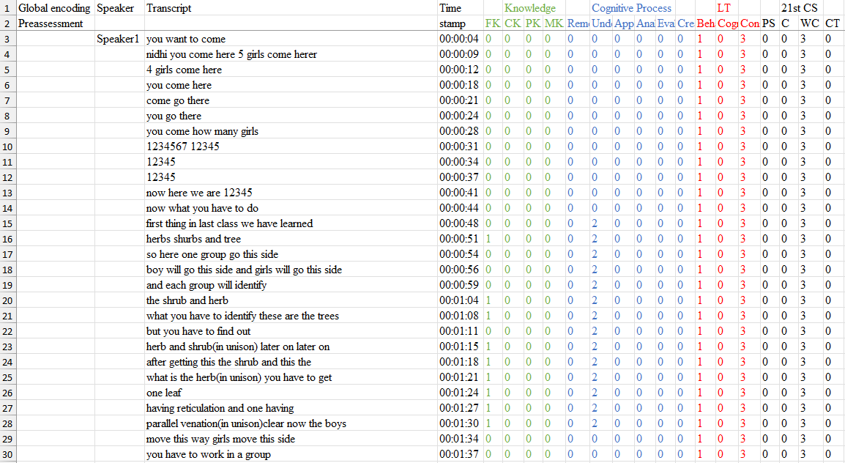
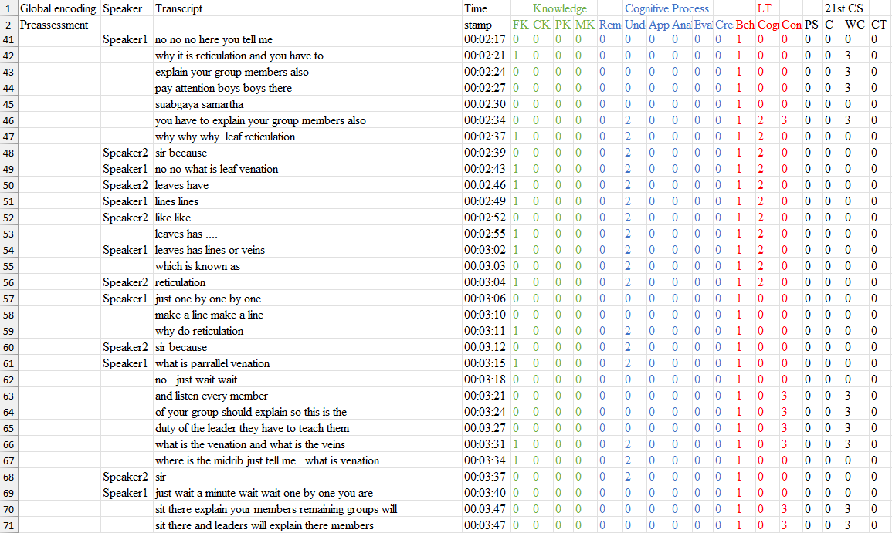
Group Formation: The teacher is forming groups and setting clear guidelines for group participation (Line 3-30). Additionally, teachers can provide scaffolding to support the development of effective collaboration skills through reciprocal teaching strategies and assigning specific roles to students (Schellens et al., 2005). In lines 42-44, 46, 63-66, and 70-71, the teacher assigns a leader role to a student and sets the guidelines for communication by stating that the leader must explain to the group; hence, these lines are encoded as WC.
20220805_131747_12th_ChemLab1
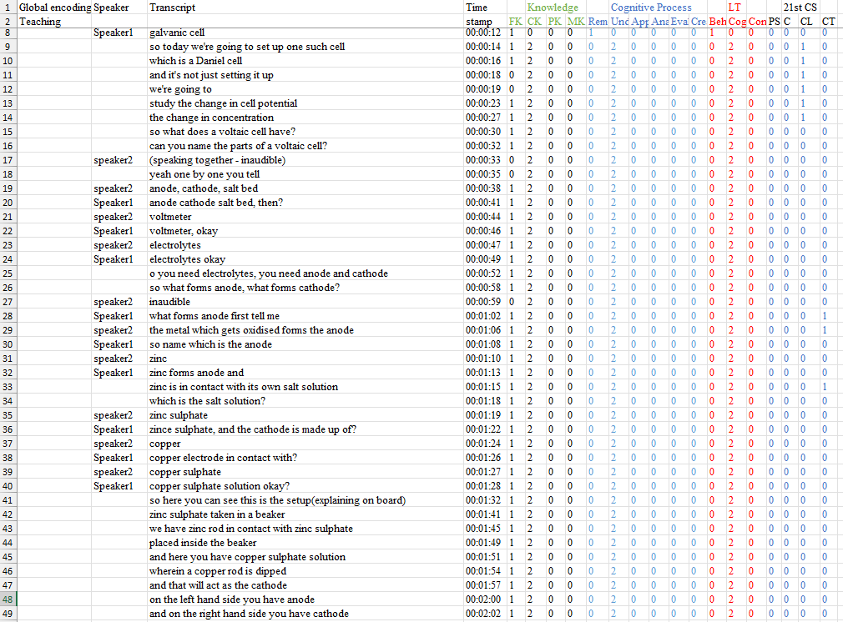
Initial lines (9-14) have been encoded as CL as the teacher is explaining the aim of the experiment (setting up the guidelines). After that, further lines have not been coded as CL because the teacher is explaining theoretical concepts prior to conducting the experiment.
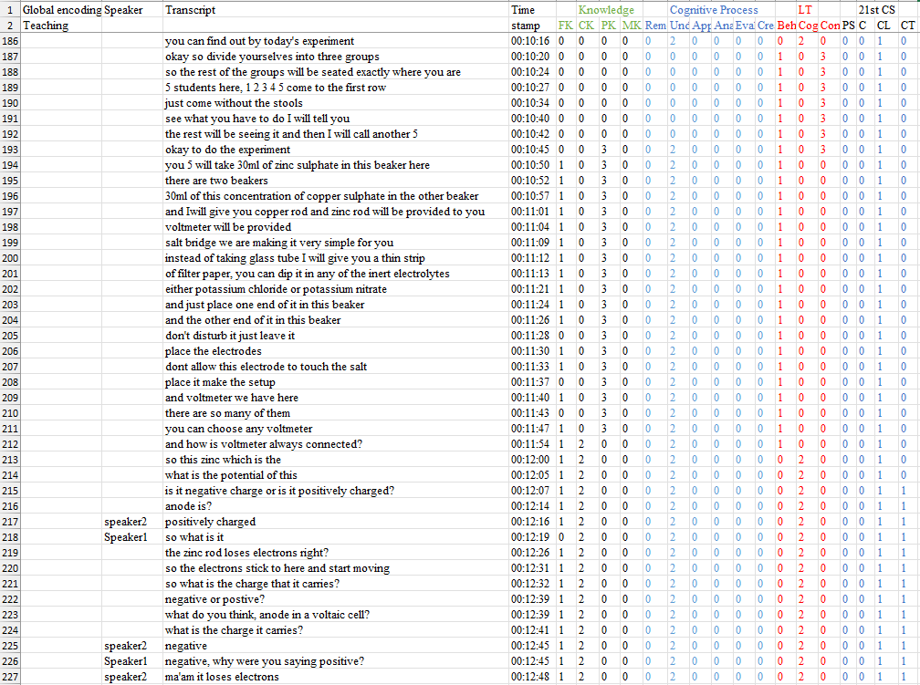
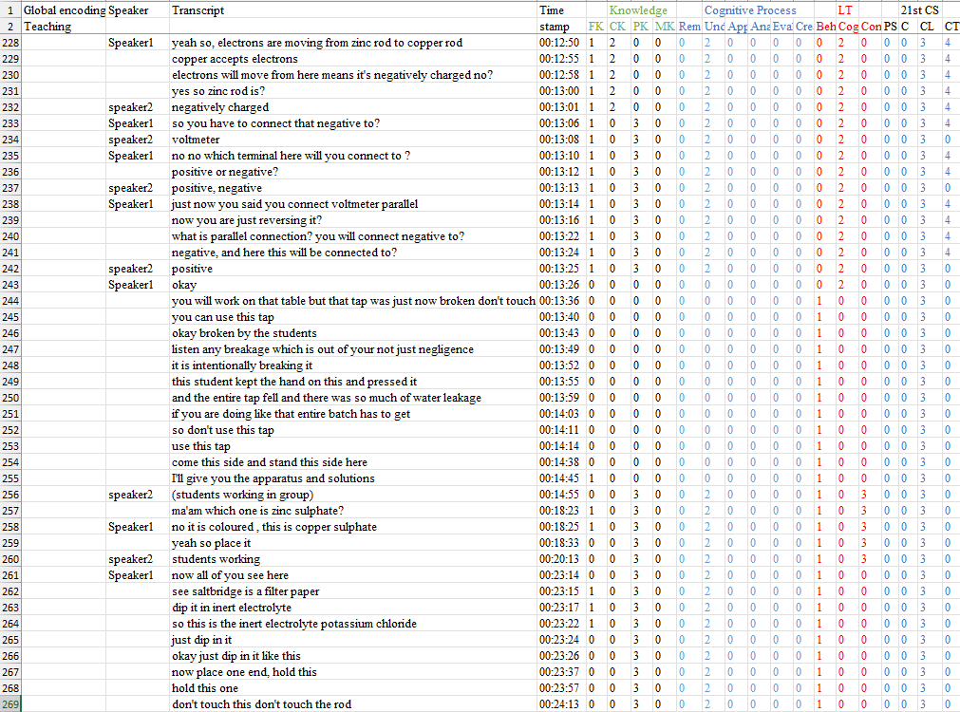
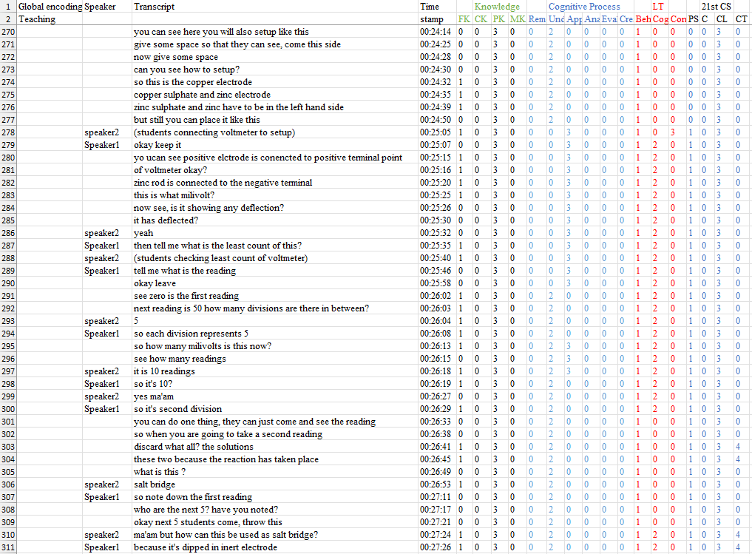
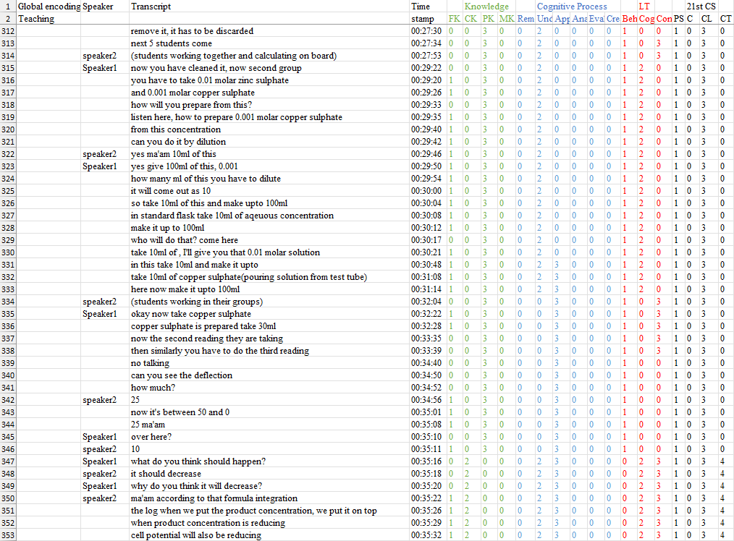
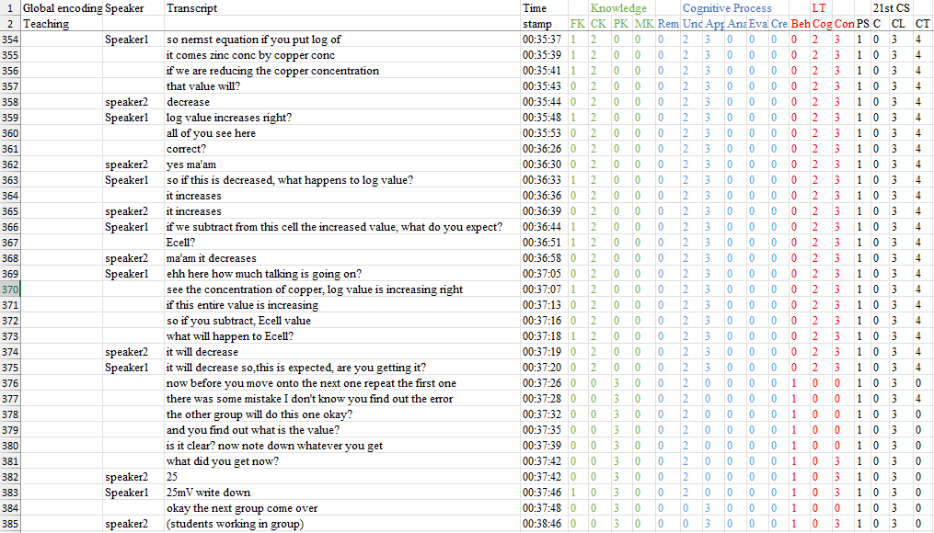
Lines from 186 to 385 have been encoded as CL. Initially, the teacher started by group formation, then explained the setup and how to do the experiment to each group one by one. This is taken as “Setting up guidelines/instructions for collaboration”. In between the lines, the teacher is also clarifying some doubts, but overall, in a whole chunk, the teacher explains to different groups how to do the experiment. Since the teacher is doing an experiment with the students in order to show them how to do the experiment, the whole chunk has been encoded as Cl.
Collaborative Learning Process | Transcript Excerpt | Rule
1. Plan & make group decisions | “okay so divide yourselves into three groups… 5 students here… the rest will be seeing it and then I will call another 5.” | Work with the group to assign roles or tasks. Teacher orients students into rotating teams, creating interdependence.
 | “you 5 will take 30 mL of zinc sulphate… and I will give you copper rod and zinc rod… voltmeter… salt bridge…” | Decide with the group how best to manage and complete the task. Clear task breakdown and resource distribution.
2. Communicate about thinking | “what do you think, anode in a voltaic cell? …what is the charge it carries?” | Solicit alternative perspectives and input from all group members. Invites each student to articulate their reasoning.
 | “why do you think it will decrease?” | Seek clarity about others’ thinking. Encourages students to explain their interpretation of the Nernst equation.
3. Contribute resources & support | (students working together and calculating on board) | Contribute ideas, efforts, and resources; support group members. Students jointly perform calculations and share workload.
 | “one group can just come and see the reading… discard the solutions… next 5 students come.” | Take responsibility for task assignments and work quality. Groups hand over their setup cleanly and prepare for the next.
4. Monitor, reflect & adapt | “before you move onto the next one repeat the first one—there was some mistake, I don’t know, you find out the error.” | Reflect on individual and group progress and processes; adapt to benefit the group. Students diagnose and correct errors together.
 | “is it clear? now note down whatever you get… what did you get now?” | Check in with group members about progress. Teacher prompts groups to verify their results before proceeding.

Final Operational Coding for Creativity
Type of rules | Problem solving (PS) | Creativity (C) | Collaborative Learning (CL) | Critical thinking (CT)
Decision rules | Encode as PS when activities involve understanding the problem, planning/executing solutions, or monitoring and reflecting on outcomes | Identify utterances, describing fluency and flexibility | Encode utterances that show group planning, shared decision-making, idea sharing, peer support, or reflection on group processes | Code as CT when interactions involve reasoned analysis, evaluation of evidence, inference, argument construction, or reflection on reasoning
Inclusion criteria | - Teacher asks students to solve a problem or prove a theorem  - The teacher asks the student to come to the blackboard and solve a problem  - Identifying and interpreting the given information before solving a problem  - If the teacher/student is giving a reflection from their side while solving a problem | - If the teacher asks to write down/list as many things/improvements/methods, etc., as possible related to the question  - Design and draw a picture and point out the name and function of each part of a machine. | - Group Formation  - Setting clear guidelines and assigning specific roles to students  - Clear task breakdown and resource distribution  - Inviting each student to articulate their reasoning.  - Groups hand over their setup cleanly and prepare for the next  - Students diagnose and correct errors together  - Teacher prompts groups to verify their results before proceeding | - Teacher explicitly identifies or explains the structure of questions and corresponding solution strategies, thereby categorising component parts of reasoning.  - The teacher asks which is correct between options A and B (Comparing)  - If the teacher is telling the meaning, analogies and application in real life of a concept (Clarifying meaning)  - If the teacher is asking a “why” or “because” type of question  - If students are correcting other students or the teacher  - Looking at the problem from multiple perspectives
Exclusion criteria | - Formula derivation/ proof  - Explaining a definition  - MK is occurring | - Write/list down two examples  - Listing closed-ended and fact-based answers from recall | If the teacher explains theoretical concepts prior to conducting the experiment. | - If the teacher is giving a reflection from their side  - Giving/listing as many examples as possible of something  - answering by recalling (single word answers)
Boundary conditions | The teacher asks to devise a plan to do an activity coded as PS | Open-ended prompts to observe and list features in a given diagram are coded as Creativity. | Interactions where the teacher demonstrates and explains an experiment while students observe or follow along, encoded as CL. | - Defining the concept in own words is Und and not CT  - Pure dictation of definitions or prompts to write terms does not count as Critical Thinking

